15.1: a) The period is twice the time to go from one extreme to the other, and to two figures. b) The amplitude is half the total vertical distance, 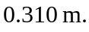 c) The amplitude does not affect the wave speed; the new amplitude is 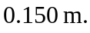 d) For the waves to exist, the water level cannot be level (horizontal), and the boat would tend to move along a wave toward the lower level, alternately in the direction of and opposed to the direction of the wave motion.

